**Development of Payroll System**

**For Government Institutions using Facial Recognition**

**FROINAND B. DAYAON**

**THERESA Z. MICOLETA**

**CHRISTIAN LORENZ S. ZORRILLA**

**A Thesis Presented to the Faculty**

**of the College of Science**

**Technological University of the Philippines**

**Ayala Blvd., Manila**

**In Partial Fulfillment of the**

**Requirements for the Degree**

**Bachelor of Science in Information Technology**

**February 2017**

**Approval Sheet**

**Acknowledgement**

Double space, 5 characters indention, ragged edge (right)

**Abstract**

No indention, single space, 150-200 words, 1 paragraph

**Table of Contents**

**Page**

Title Page 1

Approval Sheet 2

Acknowledgement 3

Abstract 4

Table of Contents 3

List of Tables 5

List of Figures 6

List of Appendixes 7

**Chapter 1 THE PROBLEM AND ITS SETTING**

Introduction 7

Background of the Study 8

Objectives of the Study 9

Scope and Limitations of the Study 10

Significance of the Study 11

**Chapter 2 CONCEPTUAL FRAMEWORK**

Review of Related Literature 12

Related Studies 29

Conceptual Model of the Study 33

Operational Definition of Terms 35

**Chapter 3 METHODOLOGY**

Project Design 37

Project Development 44

Operation and Testing Procedure 46

Evaluation Procedure 48

**Chapter 4 RESULTS AND DISCUSSION**

Project Description

Project Structure

Project Capabilities and Limitations

Project Evaluation

**Chapter 5 SUMMARY, CONCLUSIONS, AND RECOMMENDATIONS**

Summary of Findings

Conclusions

Recommendations

**REFERENCES**

**CURRICULUM VITAE**

**List of Tables**

|  |  |  |
| --- | --- | --- |
| **Table** |  | **Page** |
| 1 | 4 Point Likert Scale | 49 |
| 2 | Rating Scale for Interpreting the Evaluation Result | 49 |

**List of Figures**

|  |  |  |
| --- | --- | --- |
| **Figure** |  | **Page** |
| 1 | Conceptual Model of the Study | 33 |
| 2 | Context Level Diagram | 38 |
| 3 | Employee DFD | 39 |
| 4 | Human Resource DFD | 40 |
| 5 | Payroll Personnel DFD | 41 |
| 6 | Use Case Diagram | 42 |
| 7 | Entity Relationship Diagram | 43 |

**List of Appendixes**

|  |  |  |
| --- | --- | --- |
| **Appendix** |  | **Page** |
| A |  |  |
| B |  |  |
| C |  |  |
| D |  |  |
| E |  |  |
| F |  |  |
| G |  |  |

**Chapter 1**

THE PROBLEM AND ITS SETTING

**Introduction**

Attendance plays an important role in every organization. It helps determine whether or not a business can be successful in the future. And through the attendance monitoring, the employees will also help train themselves to become more punctual, thus resulting to a day-to-day task being fulfilled on time. Attendance will also serve as a basis in deciding which employees are most likely to stay in the company for a longer time.

Other than being a basis on determining the possible effects for the company and its employees, attendance also serves as an aspect that can affect the relationship of its employees. Some employee might fabricate their attendance records which would be unfair to others because the ones who fabricated their records would earn more or just the same as the others without rendering the same time or amount of work that should’ve been done. This kind of situation greatly affects the work environment and can change the mood or work attitude of anyone.

Also, the attendance of the employees will serve as a basis on computing the employee's’ pay slip more accurately. Thus with a proper attendance monitoring, the generation of every employee's’ salary would be made in an accurate way.

**Background of the Study**

Advancement of technology these days is continuously flourishing, all for the betterment of our daily activities, but some people are obstinate about it, insisting that manually doing the job is more reliable. Well, human error is something that can’t be prevented no matter how careful one is for it is a deviation from intention, expectation or desirability, what’s more if it is intentional caused by greed or desire to get ahead in life, and so the possibility of relying on technology shouldn’t be disregarded completely.

Currently, some organization still uses the old ways of monitoring the attendance records of its employees, such as time cards and log books that is guarded by a personnel by the entrance of the company. People, or in this case, employees, are not as honest as they say they are and could do dishonest things to turn the situation in their favor, like since the records are guarded by a personnel who could have needs and could be bribed to lower his/her morale, an employee could take advantage of that personnel in order to cheat his/her attendance record, or an employee who is “friends” to the personnel in charge thus could come and leave work regardless of the office hours but still getting paid normally. Such actions will then generate an unreliable and fabricated records that will affect the other employees – as it will be unfair to those who goes to work on time, and the organization – paying a salary that shouldn’t be paid.

The proposed system, the DTR Using Face Recognition and Payroll System for Government Institutions, will be a more practical decision for an organization to use as it will generate a reliable and not fabricated attendance records of its employees as they come and leave the company premises, thus produces a precise paycheck that each employee deserves.

**Objectives of the Study**

The general objective of this Study is to develop an Intranet-based Payroll System for Government Institutions using Facial Recognition.

Specifically, it aims to:

1. Design the system with the following features:
2. Monitor Attendance of employees using Facial Recognition;
3. Check for Leaves, Absences;
4. Calculate Deductions (SSS, PhilHealth, Pag-ibig, etc.), Gross Income, Total Salary, and etc.;
5. Generate Pay slip;
6. Notify Employees of their salary via SMS; and
7. Create a forum or board for Announcements and Event Scheduling.
8. Create the system using:
9. Sublime Text 3;
10. Adobe Photoshop CC;
11. XAMPP; and
12. Visual Studio 2015.
13. To test and improve the system’s functionality, accuracy, responsiveness, and portability.
14. Determine the acceptability level of the system using ISO 9126.

**Scope and Limitations of the Study**

The study focuses on developing, creating, testing and improving of the DTR Using Face Recognition and Payroll System for Government Institutions. The system is an intranet based and can only be accessed if the user is within the scope of the network in the organization, for security purposes.

The users can access the system through their laptop, desktop and cellular phones; it will be responsive on any medium. The access level of each feature/sub-system differs.

The scope of respondents will be all of the employees of the organization whom will have their own account with an access level.

The users can view their DTR and Payroll records through accessing their employee’s account for their performance reference in the past months.

For questions and inquiries with regards to the DTR and Payroll processes of the system, users can message the admin using their respective employee’s profile.

The system aims for the advancement of the organization through the use of modern technology. Also, a camera is attached as the device to capture image and identify the employee. The system as much as possible suggests using a high-definition camera so that there will be no inconsistency and poor lightning background problems which can result into an inaccurate result of comparing the face templates.

**Significance of the Study**

The system’s purpose is for the benefit of the organization as it will help improve the punctuality of employee, speed-up work and will help produce a precise computed employee salary. Another aspect that the organization will benefit from is that the reports of the employees’ attendance and pay slip won’t be fabricated. The process in getting each employees’ salaries would then be more reliable. In this manner, every result will be produced in an easier and faster way, thus, will increase the productivity in the organization.

**Chapter 2**

CONCEPTUAL FRAMEWORK

This chapter contains the Review of Related Literature and Related Studies, which discusses on how the system will be made. It also discusses the study concepts, based on the input, process, and output of the system, in order for the researchers to know how the proposed system will come up.

**Review of Related Literature**

Nowadays, computers are widely used in every transaction processes. Automation makes it easy for a company to do their internal and external transactions. Payroll and Attendance monitoring are one of the transactions that are being done with the use of computer. The proponents worked on a custom-made payroll and attendance system done for the specific need of the company. The proponents searched for related literature that would aid in developing an effective payroll system, one of which the research processes followed. The related literatures are as follows:

**Attendance Monitoring System**

Attendance is the number of daily time record of present employee within a particular day at school or work. Generally, it is a systematic accurate record of a person on his/her day-to-day basis obligation. It is a very significant part on employee and student’s side because it will be the basis of their productivity.

Before, Attendance Monitoring is being done by assigned personnel (e.g. faculty members and human resource administrator). They kept their records on a log book or sometimes, a worksheet. As technology grows fast, some advancements have developed, the manual approach on checking an attendance enhanced. The Attendance Monitoring System is an automated time log that is stored in the database. Using this computerized monitoring system, it keeps record in order and frequently updated in real-time. Added to this, it will be hassle-free for the human resource or teacher to check the attendance.

The modern attendance monitoring system uses different methods to mark the attendance of person. For example, some companies are using a fingerprint scanner or identification card that has a barcode. They are able to keep track of their employees.

There are various technologies on monitoring the attendance such as barcode attendance system, magnetic stripe attendance system, Radio Frequency Identification (RFID), and biometric attendance system.

The biometrics attendance system received a lot of attention because it requires user interaction with the technology. And also, it is used as a personal authentication method that is more convenient than tapping an identification card on a machine.

In biometrics attendance system, there is an attendance software that is paired with a time clock for employees and students which uses biometric technology for authentication purposes. When these systems are in use, the employees can use their biometric data such as finger prints for clocking in and clocking out.

This method has the great benefit that the entire process is easy as well as quick. Other advantages includes error reduction wherein it will lessen human error, cost-saving because the company will have the benefit of tracking attendance and computing salaries without having someone to do it, minimizing the time and effort spent on checking attendance, and reliable and secured information.

**Facial Recognition System**

The human’s face plays a vital role in interacting with other people. It is a way of knowing people’s identity. By human face, researchers find a way to make it as a key for security that’s why biometric face recognition received a lot of attention for the past several years.

The facial recognition system is an invention wherein it used for identifying the human’s face. It has the following features namely: imaging system, selector module, detector and a recognition module for capturing and analyzing set of images of individuals.

The imaging system is used to create an image of the person. The selector module has a motion detector by identifying the selected portion of an image. The detector module is used to analyze a portion of the selected image to determine whether there is a present image of a person. The recognition module is used to determine the detected image of a person from the archives if there is any records. Both detector and recognition module uses two pattern recognition techniques which employ set of eigenvectors to identify the set of recorded images.

Facial recognition has unique advantages due to its non-contact processes as compared with using fingerprint and iris biometric system. Facial recognition identification doesn’t require personal interaction and can be captured from a distance.

Added to this, the facial recognition system benefits the company by having a better security wherein the only authorized persons are able to access it, no more time fraud because it will eliminate the possibility of buddy punching, and easy integration.

There are two different technologies in using a facial recognition system. First is the 2D computer face recognition. It starts in recognizing the face in the selected image. Then, the computer will locate and digitalize the key frontal face features (e.g. curves of the eye socket, tip of the nose, chin and etc.). After digitalizing, the computer will compare the digitalized image of a person with those identified faces in the system. Second is the 3D computer face recognition that improved sensors and algorithms on recognizing the human’s face.

According to the Technology Review, the results of the Face Recognition Grand Challenge sponsored by the National Institute of Standards and Technology (NIST) had been a success because it showed that human facial recognition has greatly improved from 1995 to 2002.

According to Jonathon Phillips, a program manager for the NIST test, says that the main objective of the challenge was always an order-of-magnitude improvement in recognition performance.

Today’s facial recognition is more accurate and reliable than ever before due to the development of high-resolution still images, 3D face-recognition algorithms and 3D sensors which is capable to capture information about the shape of human faces. Current software for facial recognition focuses more on the unique features of human face such as the nose, lips, chin and curve of eye sockets where tissue and bone doesn’t change over time.

According to Ralph Gross, a researcher from Carnegie Mellon Robotics Institute Research, 3D facial recognition is better to use because of its capability to recognize human face from different angles up to 90 degrees rather than using ID cards and face scanner. By having a detailed skin-texture analysis, high resolution still images have improved the face-recognition technology.

**Payroll System**

Payroll is a process by which a company pay an employee based on the amount of money they agreed to pay and for the work they have done. It is a process that needs to be established when a business has a workforce. Added to that, every business should make sure accurate amount of money are paid to the proper government agency.

Payroll System is a tool used to assist and organize all the tasks of employee payment and filing of employee taxes. Employee’s tasks include work hours, withholding taxes and other deductions, calculating salary and wages, and printing pay slip.

There are three ways to do a payroll namely; manual system (do-it-yourself method), hire a part-time accountant and use a payroll software solution. Today’s businesses do payroll in one of the three different ways. Some businesses also have combination of those three methods (e.g. combination of the payroll software with accounting software).

Of course, most businesses prefer the payroll software solution. It is more expensive than doing payroll yourself, but it is less expensive than hiring a full-time accountant. And, they will still feel like they can save more time by using payroll software solution.

“*How does a payroll software work*?”

Typically, all payroll software solution works basically in the same way. It’s just let you do the payroll using either a web-based interface or a desktop computer software.

A payroll system requires a little time and effort from the employer. The employer just need to input employee wage information and hours. Then, the software will automatically calculate the information including withholding taxes. Most payroll software is automatically updated every time a tax law changes. The most time-consuming part of the software is entering your company information in the first time. Then, the payroll software will do the rest.

“*Why a Computerized Payroll System Is Just Better?”*

One of the important task for any business is keeping track of their employee’s work hours and paying the employees accurately. In good old days, doing a payroll is by yourself and had to be done manually with physical punch and timesheets.

Now, many of the manual operations are being computerized. Still manual method exists but using a computerized payroll system is way better.

There are numerous advantages to using a computerized payroll system such as time-saving, eliminate missing file (e.g. timecards), automatically stores data, less human error, reliable and accuracy.

It is a time-saving task because with the use of computerized system, the employee can time-in and time-out on the authorized workstation. No need for punch card or timesheet to use. In that way, the system can keep the employees on track based on work hours and it can provide total hours of work with just a click. It can even calculate gross pay at the same time. It can eliminate missing file and automatically stores data because the computerized system doesn’t use physical timecard or timesheet. The payroll system will just receive information from any hardware devices (e.g. biometric devices) or the employer will just input the information.

Plus, it can eliminate some types of manual error and fix human error easily such as employee is overpaid or underpaid, and computerized payroll functions are accurate, reliable and efficient.

**Web Development**

Web Development is a term used for the work done in making a web site for the Internet or an Intranet. It can be classified by a static website, a website written using HTML, or a dynamic website, which is a website written using more complex code, such as PHP or ASP, and has a database being drawn upon. The list of tasks involve in web development are web engineering, web design, web content development, client liaison, client-side/server-side scripting, web server and network security configuration, and e-commerce development.

A typical and basic web development hierarchy consists of Client-side Coding, Server-side Coding, and Database Technology. Client Side coding covers what would the user see, such as the design, interface and layout of the website, while the Server Side coding is the back-end systems and the functionality of the website.

Web Development can be made through the use of open source software and WYSIWYG web-development software. An example of open source software are XAMPP, WAMP, and LAMP. WYSIWYG software is an easy to use development program wherein knowledge of HTML or of other programming languages is still needed in using such program. It stands for “What You See Is What You Get”.

**Database Management System**

Database Management System (DBMS) is system software that allows the connection or interaction between databases and users/programs. A useful DBMS allows users and programmers to create, read, update, and delete data in a database. DBMS also helps in analyzing data with the use of software applications.

According to Margaret Rouse (2015), DBMS manages three things: the data, the database engine, which allows access, security and modification to the data, and the database scheme, which is the database’s logical structure. These elements help in the preservation of security and integrity for the stored data.

The use of DBMS in storing and managing data has its advantages. One of its advantages is that it lets user and programmers access and use the same data while also managing data integrity. Another benefit is that DBMS can be used to impose a structured organization on the data. Other advantages with the use of a DBMS is that data redundancy can be controlled, data gets protected and secured, efficiency in data retrieval, and fast response time when it comes to managing data.

**Object-oriented Programming**

**Object-oriented programming (OOP**), as told by webopedia, refers to a type of computer programming in which programmers define not only the data type of a data structure, but also the types of operations (functions) that can be applied to the data structure.

In this way, the data structure becomes an object that includes both data and functions. In addition, programmers can create relationships between one object and another. In order to learn object-oriented programming, we need to learn the basics first. The following definitions will help you better understand object-oriented programming:

*Abstraction*: The process of picking out (abstracting) common features of objects and procedures.

*Class*: A category of objects. The class defines all the common properties of the different objects that belong to it.

*Encapsulation*: The process of combining elements to create a new entity. A procedure is a type of encapsulation because it combines a series of computer instructions.

*Information* hiding: The process of hiding details of an object or function. Information hiding is a powerful programming technique because it reduces complexity.

*Inheritance*: a feature that represents the "is a" relationship between different classes.

*Interface*: the languages and codes that the applications use to communicate with each other and with the hardware.

*Messaging*: Message passing is a form of communication used in parallel programming and object-oriented programming.

*Object*: a self-contained entity that consists of both data and procedures to manipulate the data.

Polymorphism: A programming language's ability to process objects differently depending on their data type or class.

*Procedure*: a section of a program that performs a specific task.

One of the principal advantages of object-oriented programming techniques over procedural programming techniques is that they enable programmers to create modules that do not need to be changed when a new type of object is added. A programmer can simply create a new object that inherits many of its features from existing objects. This makes object-oriented programs easier to modify.

**PHP (PHP: Hypertext Pre-processor)**

Based on php.net, **PHP** stands for "Hypertext Preprocessor." PHP is an HTML-embedded Web scripting language. This means PHP code can be inserted into the HTML of a Web page. When a PHP page is accessed, the PHP code is read or "parsed" by the server the page resides on. The output from the PHP functions on the page are typically returned as HTML code, which can be read by the browser. Because the PHP code is transformed into HTML before the page is loaded, users cannot view the PHP code on a page. This make PHP pages secure enough to access databases and other secure information.

It is mainly focused on server-side scripting, so you can do anything any other CGI program can do, such as collect form data, generate dynamic page content, or send and receive cookies. But PHP can do much more. Here are three main areas where PHP scripts are used.

*Server-side scripting*. This is the most traditional and main target field for PHP. You need three things to make this work. The PHP parser (CGI or server module), a web server and a web browser. You need to run the web server, with a connected PHP installation. You can access the PHP program output with a web browser, viewing the PHP page through the server. All these can run on your home machine if you are just experimenting with PHP programming.

*Command line scripting*. You can make a PHP script to run it without any server or browser. You only need the PHP parser to use it this way. This type of usage is ideal for scripts regularly executed using cron (on *nix or Linux) or Task Scheduler (on Windows). These scripts can also be used for simple text processing tasks. See the section about Command line usage of PHP for more information.

*Writing desktop applications*. PHP is probably not the very best language to create a desktop application with a graphical user interface, but if you know PHP very well, and would like to use some advanced PHP features in your client-side applications you can also use PHP-GTK to write such programs. You also have the ability to write cross-platform applications this way.

**Intranet**

Intranet is a network that’s privately accessible by an organization’s staff. Its main purpose is to allow the sharing of information and computing resources among its users. Intranet is established together with other technologies for wide area networks and local area networks. In general, an intranet uses Internet protocols like TCP/IP and HTTP which makes it look like just a private version of the Internet.

According to a research by the Worldwide Intranet Challenge, it is said that the most valuable and effective intranets are like a brain to an organization which also helps make job easier for its employees. Indicating that through intranet, it would be most efficient to do practices like a company’s decision making to form business activities and policies that will determine whether that organization will succeed.

There are also other benefits being brought by Intranet to the people who are using it. These are indicating productivity in a workforce, helps save time and money, serves as a communication tool, publishing of websites, cross-platform capability, and it also allows immediate updates.

Intranet will be used for the system as a platform where the website will be published and also a tool for communication that will help in the sharing of data for its users.

**Bootstrap**

 According to getbootstrap and ostraining, **Bootstrap** is a free and open-source front-end web framework for designing websites and web applications. It contains HTML and CSS-based design templates for typography, forms, buttons, navigation and other interface components, as well as optional JavaScript extensions. Unlike many web frameworks, it concerns itself with front-end development only. It is extremely an easy and speedy procedure to begin with Bootstrap. Bootstrap is very adaptable too. You can utilize Bootstrap along with CSS, or LESS, or also with Sass.

Every year mobile devices persist to grow hugely popular, and the requirement to have a responsive website has become compulsory and important too. As the fluid grid layout amends vigorously to the appropriate screen resolution, thus crafting a mobile-ready site is a smooth and easy task along with Bootstrap. With the use of ready-made classes of Bootstrap, you can recognize the number of spots in the grid system that you would like each column to engage in. Then only you can identify at whichever point you would like your columns to load in horizontal position, instead of vertically to exhibit accurately on mobile appliances.

One of the main benefits of utilizing Bootstrap happens to be the speed of the development. While driving out a new, fresh website or application swiftly, you should certainly reflect upon utilizing Bootstrap. Instead of coding from scrape, Bootstrap lets you to use ready-made coding blocks in order to assist you in setting up. You can blend that along with CSS-Less functionality and cross-browser compatibility that can give way to saving of ample hours of coding.

**Visual Studio Community**

Visual Studio Community is a free edition of Visual Studio Integrated Development Environment (IDE) which is used for building computer programs for Microsoft Windows, and also for web applications, web services, and web sites. It also helps make work easily, whether it is in solo or as part of a group.

Visual Studio Community can be used for making applications and writing codes for iOS, Android, and Windows devices. It is also great in making apps for desktops or device apps and has a wide openness in Cloud, Web, and Mobile Development.

Visual Studio supports various programming languages. These programming languages include C, C++, VB.NET, C# and F#.

**Sublime Text**

Sublime Text is a cross-platform source code editor. It supports many markup languages and programming languages, and its functionality can be upgraded by users with plugins.

As mentioned, Sublime Text’s functionalities can be extended with plugins by the help of Package Control. Package Control is a third-party package manager that allows users to easily install any of the hundreds of great plugins. These packages were made by other developers which includes syntax highlighting definitions, menus, snippets and others. Another benefit is that the user never have to leave the application in order to search, install, upgrade and remove plug-ins.

Sublime Text has the following list of features, which helps to make coding more easily: Command Palette, is one of the most used commands in Sublime, when it is pop-up opened, users can search for settings, options, shortcuts, or even syntax for a specific language; Fast File Switching, is a functionality used to open up or to navigate through other files; Goto Anything, is a command wherein functions, methods, definitions, symbols can be searched and be switched to, whether it is on the current page, another page, or the entire project; and Simultaneous Selecting and Editing, which is a function when you want to edit multiple lines or select similar strings. Other features available in Sublime Text are Auto completion, In-editor code building, Key board shortcuts and being Cross platform.

**Evaluation System**

*ISO 9126*

ISO 9126 is an international standard for the evaluation of software. The fundamental objective of the ISO/IEC 9126 standard is to address some of the well-known human biases that can adversely affect the delivery and perception of a software development project. These biases include changing priorities after the start of a project or not having any clear definitions of "success". By clarifying, then agreeing on the project priorities and subsequently converting abstract priorities (compliance) to measurable values (output data can be validated against schema X with zero intervention), ISO/IEC 9126 tries to develop a common understanding of the project's objectives and goals. The standard is divided into four parts which addresses, respectively, the following subjects: quality model; external metrics; internal metrics; and quality in use metrics.

ISO 9126 Part one, referred to as ISO 9126-1 is an extension of previous work done by McCall (1977), Boehm (1978), FURPS and others in defining a set of software quality characteristics. ISO9126-1 represents the latest (and on-going) research into characterizing software for the purposes of software quality control, software quality assurance and software process improvement (SPI).

The quality model in the first part of the standard, ISO/IEC 9126-1, identifies 6 main quality characteristics:

*Functionality*is a set of attributes that bear on the existence of a set of functions and their specified properties. The functions are those that satisfy stated or implied needs.

*Reliability* is a set of attributes that bear on the capability of software to maintain its level of performance under stated conditions for a stated period of time.

*Usability* is a set of attributes that bear on the effort needed for use, and on the individual assessment of such use, by a stated or implied set of users.

*Efficiency* is a set of attributes that bear on the relationship between the level of performance of the software and the amount of resources used, under stated conditions.

*Maintainability* is a set of attributes that bear on the effort needed to make specified modifications.

*Portability* is a set of attributes that bear on the ability of software to be transferred from one environment to another.

*4 Point Likert Scale*

A Likert scale is a psychometric scale commonly used in questionnaires, and is the most widely used scale in survey research. When responding to a Likert questionnaire item, respondents specify their level of agreement to a statement. The scale is named after its inventor, psychologist Rensis Likert.

An important distinction must be made between a Likert scale and a Likert item. The Likert scale is the sum of responses on several Likert items. Because Likert items are often accompanied by a visual analogue scale (e.g., a horizontal line, on which a subject indicates his or her response by circling or checking tick-marks), the items are sometimes called scales themselves. This is the source of much confusion; it is better, therefore, to reserve the term Likert scale to apply to the summated scale, and Likert item to refer to an individual item.

A Likert item is simply a statement which the respondent is asked to evaluate according to any kind of subjective or objective criteria; generally the level of agreement or disagreement is measured.

The response options of a typical four-level Likert item are: *Not Acceptable, Moderately Acceptable, Very Acceptable,* and *Highly Acceptable.*

*Respondent’s Profile*

Respondents were composed of 3 IT Professionals and 47 CS/IT/IS students; both having knowledge on how a DTR and payroll system should work.

**Related Studies**

According to Kong (2007), an attendance-monitoring system servers as a time log that is set up as a computerized database. An attendance-monitoring system maintains a daily records of a person’s arrival and departure time from work or school. An attendance-monitoring system contains a person’s name, address,date of birth,medical history and attendance history. It keeps records in order and is frequently updated.

A filipino programmer named Andrew Mendrez (2007) made a study for Vision Designer Inc. It has an identification machine aimed at verifying a person entering through the swiping of identification cards. After entering their given code number, the identification cards are swiped in the machine’s card reader to trigger the verification. If access granted the micro switch will then automatically unlock to allow enter. This will help a lot in monitoring attendances accurately and more precise.

The study by John Aquilan entitled “Automation of time attendance system” stated that the automation of the time attendance records, time in and time out of every employee using barcode system. It tends to eliminate the manual recording system of time and attendance and also include salary computation of each employee based on the time and attendance reports.

Nowadays some institutions are still using a manual monitoring system and most of the time they accidentally loss their attendance sheet resulting into inaccuracy of the attendance of their employees leading into errors/problems when it comes to computing pay slips.

The agenda of these studies greatly aligns with the agenda of the researcher’s study for the development of an automated attendance-monitoring system in order to solve the aforementioned problems.

The study of Ling, Soatto, et al entitled “**A Study of Face Recognition as People Age** “focuses on the effectiveness of facial recognition. According to them Face recognition across ages is an important problem and has many applications, such as passport photo verification, image retrieval, surveillance, etc. This is a challenging task because human faces can vary a lot over time in many aspects, including facial texture (e.g. wrinkles), shape (e.g. weight gain), facial hair, presence of glasses, etc. In addition, the image acquisition conditions and environment often undergo large changes, which can cause non-uniform illumination and scale changes.

Face recognition and detection has been widely studied for several decades. A lot of work has been done to handle the problem under different conditions, including lighting, pose, expression, etc. The aging process and its effect on face analysis, which we are interested in, has recently attracted research effort. Most work has focused on modelling the aging process [20], age estimation [10, 12, 19, 27], and simulation [11, 21]. In comparison, face verification across ages is far less studied. Ramanathan and Chellappa adapted the probabilistic eigenspace framework [16] for face identification across age progression, which is most closely related to our work. Instead of using a whole face, only a half face (called a PointFive face) is used to alleviate the non-uniform illumination problem. Then, eigenspace techniques and a Bayesian model are combined to capture the intra-personal and extra-personal image differences. Targeting the same task, our work differs from their work in both the representation (we use gradient orientation pyramids) and the classification frameworks (we use SVM).

Modelling face verification as a two-class classification problem is not new. Moghaddam et al. Used a Bayesian framework for the intra-personal and extra-personal face classification. Phillips used SVM for face recognition problems and observed good results on the FERET dataset compared to component based approaches. Jonsson et al. used SVM for face authentication problems.

Our work is different in that we use the gradient orientation pyramid instead of intensity differences or the intensity itself as a face description. Furthermore, we are more interested in passport photos with age differences. Image gradients are widely used for feature building and image representation. In most of these works, the gradient magnitude information is included (e.g. to build a weighted histogram). The direction of image gradient has been proposed for lighting insensitive recognition and was shown to be insensitive to changes in lighting direction under a Lambertian assumption. Recently, Hammond and Simoncelli proposed a nonlinear image representation using only the orientation information. Inspired by these works, we propose using the gradient orientation for robust face representation with age variation. To the best of our knowledge, it is the first time the gradient direction is combined with SVM for face verification problems. Our experiments show that by discarding magnitude information, the gradient orientation achieves significantly better recognition performance. We also propose using hierarchical structure to further improve discriminability. Our work also relates to work on skin appearance. It is known that melanin and hemoglobin are the two most important factors that determine human skin color. Tsumura et al. used independent component analysis (ICA) to separate the effect of melanin and hemoglobin as two independent components from skin color. They showed that the logarithm of skin color can be decomposed as linear combinations of two components corresponding to melanin and hemoglobin respectively. We show that this fact is closely related to the insensitivity of gradient orientation across the aging process. This study by them gave the researchers an idea on the things to be considered in developing a face-recognition feature.

According to McGuigan, biometric face recognition works by using a computer to analyze a subject’s facial structure. Face recognition software takes a number of points and measurements, including the distances between key characteristics such as eyes, nose and mouth, angles of key features such as the jaw and forehead, and lengths of various portions of the face. Using all of this information, the program creates a unique template incorporating all of the numerical data. This template may then be compared to enormous databases of facial images to identify the subject. Face recognition can be designed and use for time attendance system, extending employee time attendance reporting system. The system will replace traditional paper based or ID card number based time attendance system. This study by McGuigan gave the researchers an insight in developing an attendance-monitoring system using face recognition.

**Conceptual Model of the Study**

Figure 1 shows the conceptual model of the study. This indicates the software and hardware requirements including the necessary skills needed to develop the system.

|  |
| --- |
| **INPUT** |
| **Knowledge Requirements**   * Web Design and Development * Bootstrap * OOP * Intranet * Database Management * Payroll * Evaluation System   **Software Requirements**   * Windows 7, 8 or 10 * Sublime 3 * Visual Studio 2015 Community Edition * XAMPP   **Hardware Requirements**   * Processor: Intel i3 or Higher * Monitor: 18” Colored or higher32-bit * RAM: 4GB or higher * HDD: 500 GB or higher * Camera: 20mp+ |

|  |
| --- |
| **PROCESS** |
| System Design  System Creation  System Testing and Improvement |

|  |
| --- |
| **OUTPUT** |
| DTR Using Face Recognition and Payroll System for Government Institutions |

**EVALUATION**

***Figure 1****.* Conceptual Model of the Study

**Input**

The input is divided into three parts – Knowledge Requirements, Software Requirements, and Hardware Requirements. Knowledge Requirements includes Web Design and Development Bootstrap, OOP, Intranet, Database Management, Payroll, and Evaluation System. Software Requirements includes the Operating System: Windows 7, 8 or 10; Development tool: Sublime 3, Visual Studio 2015 Community Edition; and for Database: XAMPP. Hardware Requirements includes *Processor*: Intel i3 or Higher; *Monitor:* 18” Colored or higher 32-bit; *RAM*: 4GB or higher; *HDD:* 500 GB or higher; and *Camera*: 20mp+.

**Process**

The process consists of System Design, System Creation, System Testing and Improvement. System Design is the phase for gathering information and planning on how the system will be developed. System Creation is the process of creating the system. System Testing and Improvement is the examination for any possible bugs on the system that needs to be fixed.

**Output**

The output is the DTR Using Face Recognition and Payroll System for Government Institutions. The system is developed to help improve the punctuality of employee, speed-up work and will help generate a precise computed employee salary.

**Operational Definition of Terms**

The operational definition of terms defines terminologies utilized in the context of discussing and describing the research project. The following are important terms to better understand the entire study.

***Facial Recognition*** refers to a type of biometric system that will be used to identify a person for their attendance with the use of an image.

***Sublime Text 3*** is a code editor software in which the language PHP will be coded with.

***XAMPP (Cross-Platform, Apache, MySQL, PHP and Perl)*** is a web server package that will help developers view data even without a connection from the Internet.

***Visual Studio 2015*** is a development environment in which the DTR system will be coded with.

***ISO 9126*** refers to the standard that will be used to evaluate the system.

***Responsive*** is a web designing approach that will allow the website to be viewable on different types of devices.

***Intranet*** is a private network wherein the system will be deployed into and will be used to allow the organization to access information and the system.

***Database*** is a storage where data will be kept. It also allows user to manage and access data.

***Payroll*** refers to the amount of money paid to all employees in a payday, the financial records of a company relating to the payment of wages and salaries to employees, or the total record of earnings of all employees for a year.

***Gross Pay*** is the total paid to an employee each pay period. For hourly employees, gross pay is pay rate times hours worked.

***Net Pay*** is the amount of pay an employee receives after all withholding and deductions from gross pay. In other words, net pay is the amount of the employee's paycheck.

***Withholding Tax*** refers to amounts taken from an employee's paycheck for federal and state income taxes. Withholding is determined for federal income tax by a Form W-4 completed by the employee at hire, and for state income tax by a state W-4 or other tax form.

***Cash Advance*** is the advance of approximately eighty percent of expected earnings to an employee instead of a Hand-drawn Check. The advance is processed through the Controller's Office. The dollar amount of the advance is recovered on the following check by a one-time deduction.

***Deduction*** is a gross-to-net element amount which is subtracted from gross earnings. For government offices this includes GSIS, Pag-ibig, PhilHealth and Withholding Tax, a mandatory for deductions

***Salary Grade*** defines an employee’s monthly salary rate depending on his/her job description. It is divide into 33 types with 6 steps each.

***Leave of Absence (LOA)*** is generally defined as a right granted to officials and employees not to report for work with or without pay provided by law and as the rules prescribe.

**Chapter 3**

METHODOLOGY

This chapter contains the project design, program development, operation and testing procedure, and evaluation procedure.

**Project Design**

The system design is composed of Context Level Diagram, Data Flow diagram, Entity Relationship Diagram (ERD), and Flowchart for the DTR Using Face Recognition and Payroll System for Government Institutions.

The system is designed to get the users attendance data using the FIFO algorithm where in the morning only the first log-in data will be inserted to the database and in the afternoon only the first log-in data will be inserted to the database this is to avoid the issue where some employees try to login once, twice or thrice worrying that their attendance data would not be recorded because of a system failure. After a successful login the system will show the user his/her recorded time data notifying her that the recorded is successfully inserted into the database.

Deduction Chart

Messages

Computed Pay slip

Employee Details

Attendance Data

Generated Pay slip

Messages

Payroll Personnel

Employee Details

Deduction Charts

Employee Details

Attendance Data

Generated Pay slip

Messages

Deduction Charts

Attendance Data

Training Data

SMS Notification

Time Data

Human Resource

Employee

DTR and Payroll System for Government Institutions

***Figure 2****.* Context level diagram

In Figure 3 an employee is able time-in/time-out of the system using the FIFO algorithm wherein the first time-in data in the morning and the last time-out data in the afternoon will be the only one recorded an employee can also view attendance data, request a copy of their own payslip, view the deduction table, request employee details but the only data that they can change is their password. They can also send/receive message across the server thus communicating with the other employees.

*Figure 3.* Employee DFD

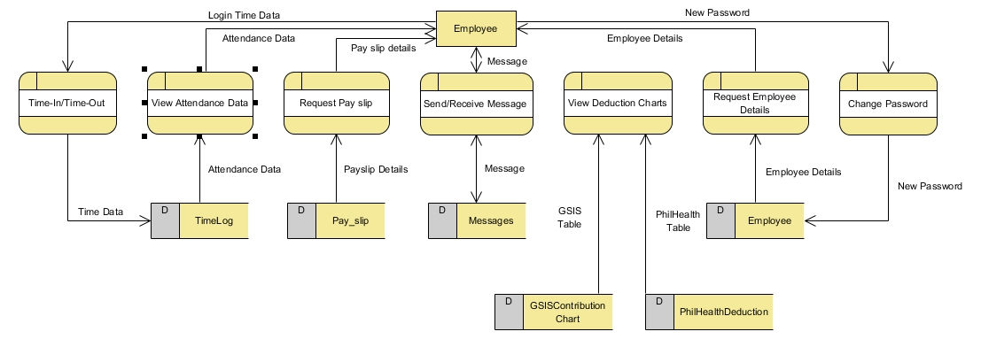

In Figure 4, the personnel is able time-in/time-out of the system using the FIFO algorithm wherein the first time-in data in the morning and the last time-out data in the afternoon will be the only one recorded. they can also view their attendance data, request a copy of their own payslip, view the deduction table, request employee details and lastly compute the necessary details,like gross pay, deduction and net salary, for the generation and printing of pay slip.

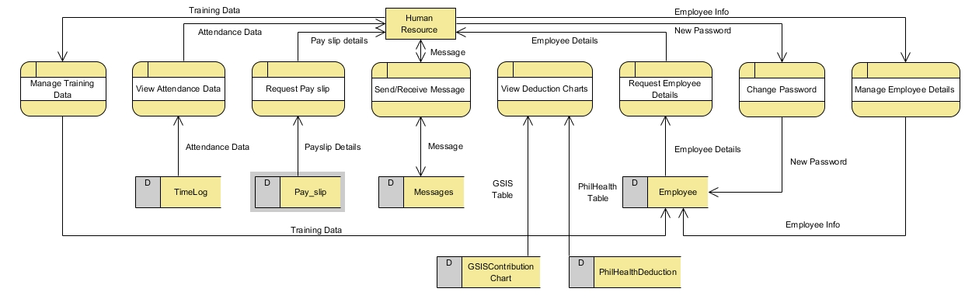

*Figure 4.* Human Resource DFD

In Figure 5, the entity "human resource" do the same things as the personnel except for Managing Training Data for face comparison the attendance-monitoring system, adding new employees and updating employee's information

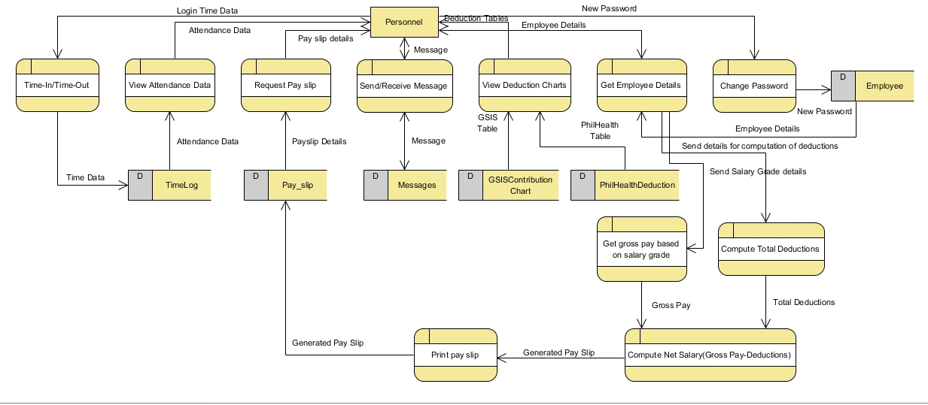

*Figure 5.* Payroll Personnel DFD

There would be three different types of users for the DTR and Payroll System. These are: Employee, Human Resource, and Payroll Personnel.

In the Daily Time Record System, all of the users are allowed to Time-in/Time-out of the system. While in the Payroll system, all three users are allowed to Log-in/Log-out of the system, View their own attendance data, View their payslips, View Employee information, View the deduction tables, and send/receive messages to each other as well.

Other than the listed cases in which all the users are involved, The Human Resource can also perform adding and updating of Employee information and deduction tables. While for a Payroll Personnel, he/she will be able to Generate and Print Payslips and Compute Deductions, Grosspay, and Netpay.

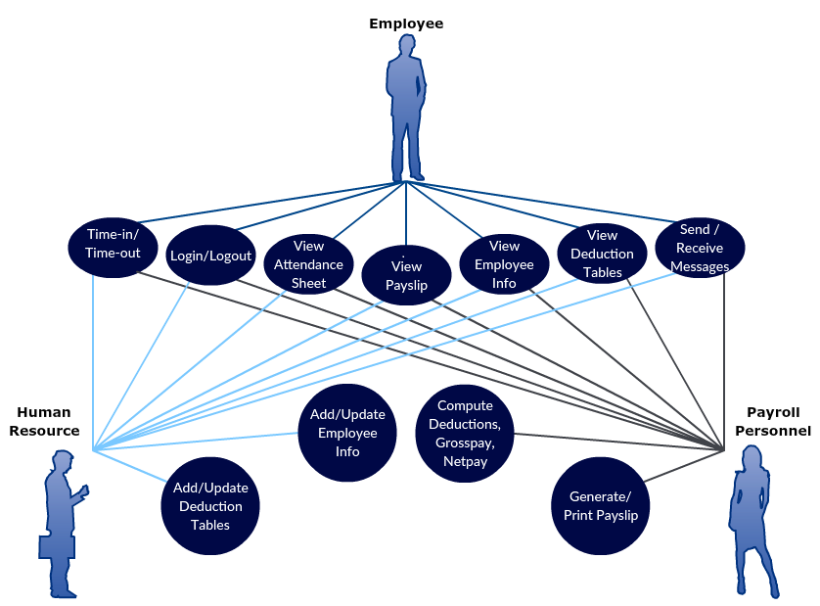

*Figure 6.* Use Case Diagram

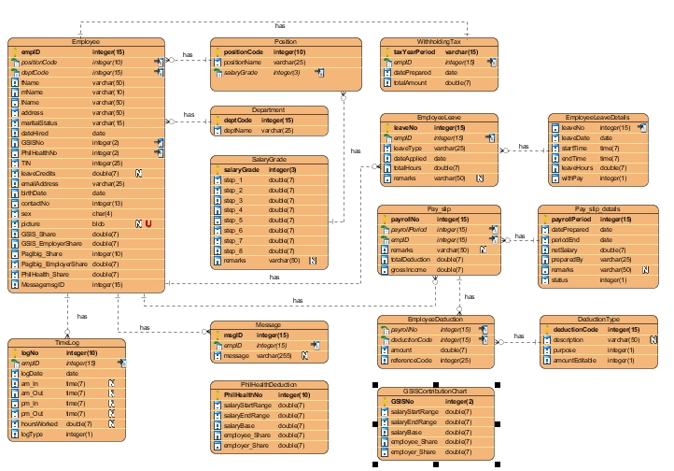

*Figure 7.* Entity Relationship Diagram

**Project Development**

The project development consists of a set of related activities that leads to the production of the system. The researchers chose the Waterfall Model Approach in developing the proposed system, the DTR Using Face Recognition and Payroll System for Government Institutions, as it simple and easy to understand and use, and easy to manage due to the rigidity of the model; each phase has specific deliverables and a review process.. In the Waterfall model approach, the whole process of project development is divided into separate phases, typically, the outcome of one phase acts as the input for the next phase sequentially. All the phases are cascaded to each other in which progress is seen as flowing steadily downwards (like a waterfall) through the phases. The next phase is started only after the defined set of goals are achieved for previous phase and it is signed off, so the name "Waterfall Model". Also, phases do not overlap.

The sequential phases in Waterfall model are:

*Requirement Gathering and Analysis:* All possible requirements of the system to be developed are captured in this phase and documented in a requirement specification doc.

*System Design:* The requirement specifications from first phase are studied in this phase and system design is prepared. System Design helps in specifying hardware and system requirements and also helps in defining overall system architecture.

*Implementation:* With inputs from system design, the system is first developed in small programs called units, which are integrated in the next phase. Each unit is developed and tested for its functionality which is referred to as Unit Testing.

*Integration and Testing:* All the units developed in the implementation phase are integrated into a system after testing of each unit. Post integration the entire system is tested for any faults and failures.

*Deployment of the System:* Once the functional and non-functional testing is done, the product is deployed in the customer environment or released into the market.

*Maintenance:* There are some issues which come up in the client environment. To fix those issues patches are released. Also to enhance the product some better versions are released. Maintenance is done to deliver these changes in the customer environment.

**Operation and Testing Procedures**

This section is used to check if the system meets the criteria according to the systems functionality, accuracy, responsiveness and reliability. The researcher will conduct a test on the system as a part of the Operation and Testing Procedures.

**For Functionality Testing:**

1. The researcher will perform the Time-in function by facing the camera.
2. If the system recognizes a match in its records. The system will automatically input the time of the process for the match’s Time-in record for the current day.
3. The researcher will now perform the Log-in function by entering the username and password, in order to check whether his time-in for the day was recorded.
4. If the entered credentials matches the information of any of the users: Employee, Payroll Personal, and Admin, the system will automatically directed to his/her personal account.
5. In the Employee account, there will be Attendance and Payslip options.
6. The researcher will click Attendance and it will be directed to the page, he/she will be able to view his/her daily attendance record up to the current day.
7. The researcher will click Payslip and it will be directed to the page, he/she will be able to view his/her payslip upto the recent payroll period. The user will be notified through a message if there is a new payslip record in his/her account.
8. In performing the Time-out function, the researcher will then face the camera again.
9. If the system recognizes a match in the records again. The system will automatically input the time of the process for the match’s Time-out record for the current day.

**For Accuracy Testing:**

1. The researcher will access the Attendance module.
2. The attendance record for each current day will display the time-in and time-out record of the user for each day, provided that it would be the same time as of when the user timed-in or timed-out his/her attendance.

**For Reliability Testing:**

1. The researcher will access the Payslip module.
2. The payslip record for each payroll period will display the exact amount of his/her salary. Provided that it will also display how that salary did came up depending on his/her attendance and deductions on the payslip.

**For Responsiveness Testing:**

1. The researcher will access the site through a mobile device.
2. The researcher will logon to his/her account the same way he/she does it through a computer.
3. The researcher will check if the site is properly displayed through a mobile device.
4. The researcher will check his/her Attendance and Payslip to check if those modules are working properly just like on the web-based system.
5. The researcher will perform the Logout function.

**Evaluation Procedure**

To measure the system’s performance, an evaluation instrument using ISO 9126 is used. The survey form can be found in the Appendix. The criteria are Functionality, Reliability, Usability, Maintainability, and Portability. The following are the steps done during the evaluation:

1. Evaluation forms is distributed to forty-five (47) CS/IT/IS students and three (3) IT Professionals;
2. Prior to the completion of evaluation forms, the researchers demonstrated how to use the system to the group of evaluators composing of IT Professionals and CS/IT/IS students;
3. After the demonstration, the researcher asked the evaluators to use the intranet based system.
4. Finally, the evaluators will rate the system based on 4 Point Likert Scale. The response was chosen from a scale of 1 to 5, 5 being the highest which means Highly Acceptable, and 1 being the lowest which means Not Acceptable.

**Table 1**

*4 Point Likert Scale*

|  |  |
| --- | --- |
| Item |  |
| 4 | Highly Acceptable |
| 3 | Very Acceptable |
| 2 | Moderately Acceptable |
| 1 | Not Acceptable |

1. Data was tabulated to compute for the mean of each criterion and the overall mean computation for the given criteria.
2. In interpreting the results of the evaluation. The study used the Rating Scale for Interpreting the Evaluation Result.

**Table 2** – Rating Scale for Interpreting the Evaluation Result

|  |  |
| --- | --- |
| Item |  |
| 3.76 – 4.00 | Highly Acceptable |
| 2.76 – 3.75 | Very Acceptable |
| 1.76 – 2.75 | Moderately Acceptable |
| 1.00 – 1.75 | Not Acceptable |

**References**

https://www.scribd.com/doc/101382791/CHAP1-5PAYROLL-SYSTEM-THESIS-FINAL

https://www.scribd.com/doc/127024132/revlit

https://www.tutorialspoint.com/sdlc/sdlc_waterfall_model.htm

http://www.scitechnol.com/information-technology/articles-on-database-management-systems.php

http://searchsqlserver.techtarget.com/definition/database-management-system

https://www.managementstudyguide.com/advantages-and-working-of-dbms.htm

http://searchwindevelopment.techtarget.com/definition/intranet

http://www.ragan.com/Main/Articles/9_types_of_content_every_intranet_should_have__43560.aspx

http://www.quickbooks.co.za/product/payroll-software/what-is-payroll-software/

http://www.hrpayrollsystems.net/payroll-systems/

http://bebusinessed.com/online-payroll/how-to-do-payroll/

https://www.timeclockwizard.com/computerized-payroll-system-is-better/

https://scotch.io/bar-talk/the-complete-visual-guide-to-sublime-text-3-getting-started-and-keyboard-shortcuts

https://www.visualstudio.com/vs/community/

https://www.visualstudio.com/vs/

https://msdn.microsoft.com/en-us/library/dd831853.aspx